
Fabrication of copper matrix composite reinforced by graphene–carbon nanotube hybrid materials by spark plasma sintering technique
Doan Dinh Phuong¹, Tran Bao Trung¹, Phan Ngoc Minh^{1, 2}, Pham Van Trinh^{1, 2, *}
¹Institute of Material Science, Vietnam Academy of Science and Technology,
18 Hoang Quoc Viet Str., Cau Giay Distr., Ha Noi, Viet Nam
²Graduate University of Science and Technology, Vietnam Academy of Science and Technology
18 Hoang Quoc Viet Str., Cau Giay Distr., Ha Noi, Viet Nam
*Emails: trinhpv@ims.vast.vn
Received: 31 December 2024; Accepted for publication: 23 May 2025

Abstract. In this work, graphene-carbon nanotube/copper (Gr-CNT/Cu) composites were fabricated by using the spark plasma sintering (SPS) technique. The effect of Gr-CNT hybrid material on the microstructure, mechanical properties and wear behavior of the composites was investigated. The obtained result showed that the Gr-CNT hybrid material was uniformly dispersed on the surface of Cu particles. The relative density of the fabricated Gr-CNT/Cu composite was higher than 98 %. The Gr-CNT/Cu composite exhibited enhanced hardness and tensile strength relative to pure Cu and Cu composite reinforced by single CNTs or Gr. The enhancement in hardness and tensile strength was attributed to the incorporation of Gr-CNT hybrid material. Furthermore, the friction coefficient and wear rate of the composite decreased by 43 % and 50 %, respectively, in comparison to pure Cu. The reduction in the friction coefficient of the composite indicated the excellent wear resistance of the Gr-CNT hybrid material within the Cu matrix.
Keywords: Graphene nanoplatelets, Cu composites, spark plasma sintering, microstructure, mechanical properties
Classification numbers: 2.9.4, 2.10.1, 2.10.3.
1. Introduction
The advancement of modern technology has resulted in increased demands for the characteristics of materials, which individual materials such as metals, ceramics, and polymers cannot fulfill independently. The emergence of composite materials has met those requirements [1]. Especially metal matrix composite materials with outstanding mechanical properties, electrical properties and thermal properties compared to other materials [2 - 4]. Therefore, this material has become one of the most important and interesting materials in recent years. They are increasingly widely used in many industries such as aerospace, national security, machine manufacturing, electricity, electronics, etc [3, 5]. Copper (Cu) is extensively utilized in cables and electrical and electronic components owing to its superior ductility, thermal conductivity, and electrical conductivity [6, 7]. Due to the swift advancement of the electronics and energy sectors, electrolytic copper foil, a crucial raw material for copper-clad plates, printed circuit boards, and lithium battery cathode current collectors, is experiencing heightened demand and rising prices. Some critical issues are low mechanical properties, oxidation resistance and conductivity, which significantly influence performance and service life in precision electronic components.
To improve the performance, copper-based composites have been developed by involving the integration of reinforcements, which are primarily classified into two categories: metal ceramics (Al₂O₃, SiC, TiC, ZrO₂) and carbon nanomaterials (carbon fiber, carbon nanotubes (CNTs), and graphene (Gr)) [6, 8 - 13]. The addition of metal ceramics generally improves the mechanical qualities (hardness, elastic modulus, wear resistance, etc.) of copper matrix composite, but consistently diminishes electrical conductivity due to their lower electrical conductivity. Alternatively, it is posited that graphene and carbon nanotubes are the most potential reinforcement materials owing to their exceptional strength and superior electrical conductivity [14 - 16]. Copper matrix composites reinforced by single phases like CNTs or Gr have been investigated and presented in the previous reports [14, 17, 18]. The obtained results demonstrated the enhancement in the performance of copper composite in terms of mechanical properties. Recently, the Gr-CNT hybrid material exhibited as a promising reinforcement material for composite systems due to the combination of the unique properties of both CNTs and Gr [19]. To improve the comprehensive characteristics of nano-carbon materials reinforced metal matrix composites, a mix of graphene oxide and carbon nanotubes was employed as reinforcement. In the preparation of Gr-CNTs hybrid material, the p-orbitals in CNTs overlapped to create highly delocalized π bonding, allowing CNTs to interact with certain macromolecules exhibiting conjugation properties via non-covalent bonding, thereby forming a Gr-CNT network reinforcement through π-π bonding. The hybrid network between Gr and CNTs was established through π-π bonding, are expected to generate a substantial synergistic enhancement of the strength of the composites [20 - 24].
Thus, in this work, copper matrix nanocomposites reinforced with CNT-Gr hybrid material were prepared by using a powder metallurgy route. The composite powders were prepared by using high-energy ball milling and then consolidated by spark plasma sintering (SPS) technique. The effect of Gr-CNT hybrid material on the mechanical properties and wear behavior of composite were investigated. In addition, to clarify the strengthening effect of the Gr-CNT hybrid material in the composite, CNT/Cu and Gr/Cu composites were fabricated under the same conditions for comparative analysis.
2. MATERIALS AND METHODS
2.1. Materials
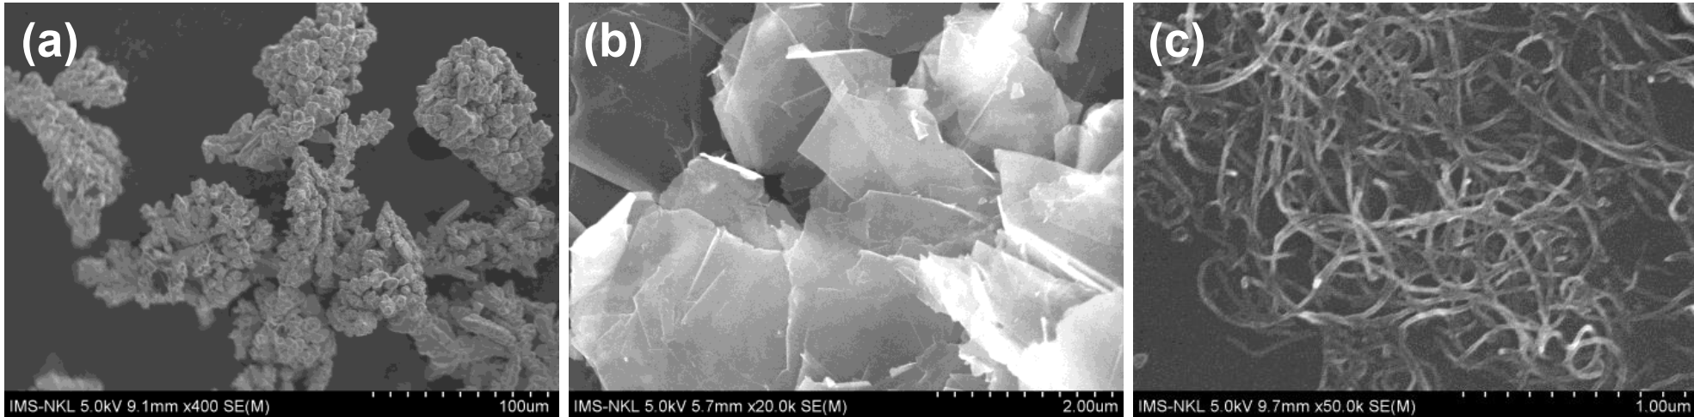
Figure 1. SEM images of (a) Cu powder, (b) graphene and (c) carbon nanotubes.
Commercial dendritic shaped copper powder (99.9 %) with an average diameter of 35 μm purchased from Xilong Scientific Co. Ltd, China is used as a matrix material (Figure 1a), lab-made Gr having an average diameter of 2 µm (Figure 1b) and CNTs with an average diameter of 30 nm were used as reinforcement materials (Figure 1c).
2.2. Methods
The copper matrix composites reinforced by Gr-CNT hybrid material were prepared by powder metallurgy route. The Gr-CNT/Cu powders were prepared by using the process shown in Figure 2a. Firstly, Gr and CNTs were functionalized with carboxylic (COOH) functional groups [25, 26], followed by dispersion in ethanol to create a CNT-Gr (1:1) suspension with a concentration of 1 g/l. Secondly, the Cu particles were incorporated into the Gr-CNT suspension under continuous magnetic stirring with a speed of 200 rpm and heating temperature of 60 °C to produce a Gr-CNT/Cu slurry with Gr-CNT content of 1 vol.%. The Gr-CNT/Cu slurry was then milled at 300 rpm for 3 hours using a W-Co alloy jar and balls, the ratio of ball to powder of 10:1. Thereafter, the obtained samples were dried under vacuum at 200 mbar for 3 hours, and then reduced in H₂ at 300 °C for 3 hours to get the Gr-CNT/Cu composite powder. The obtained powders were placed into a graphite mold with a diameter of 20 mm. The samples were subsequently sintered using an SPS system (LaBox-350, Sinter Land). The sintering process is conducted at a temperature of 700 °C for 5 minutes under a pressure of 50 MPa to produce Gr-CNT/Cu composite Figure 2b-c. The Cu composites reinforced by CNTs and Gr with the same concentration of 1 vol% were prepared by using the same conditions to compare.
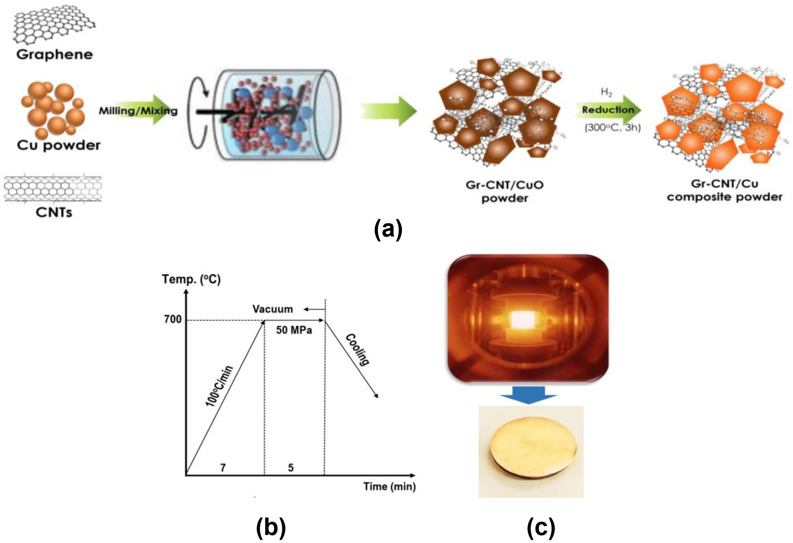
Figure 2. (a) Preparation process of Gr-CNT/Cu powder, (b) sintering cycle and (c) Gr-CNT/Cu composite after sintering.
2.3. Characterization
The morphology and microstructure of powders and sintered composites were studied using optical microscopy (Axiovert 40MAT, Carl Zeiss, Germany) and scanning electron microscopy (SEM, Hitachi S-4800, Japan). Energy-dispersive X-ray spectroscopy (EDS) was used to analyze the compositions of Gr-CNT/Cu composite by using Hitachi S-4800, Japan. The microhardness was measured using a Vickers hardness tester (Shimadzu HMV 2000, Japan). Tensile tests were conducted with an Instron 8848 Microforce Tester. The wear behaviors of the prepared composites were measured by using a Pin-on-disk tribometer (TRB3, Anton Paar) with loads of 5N with a distance of 20m and a rotation speed of 10 cm/s.
3. Results and Discussion
3.1. Microstructure
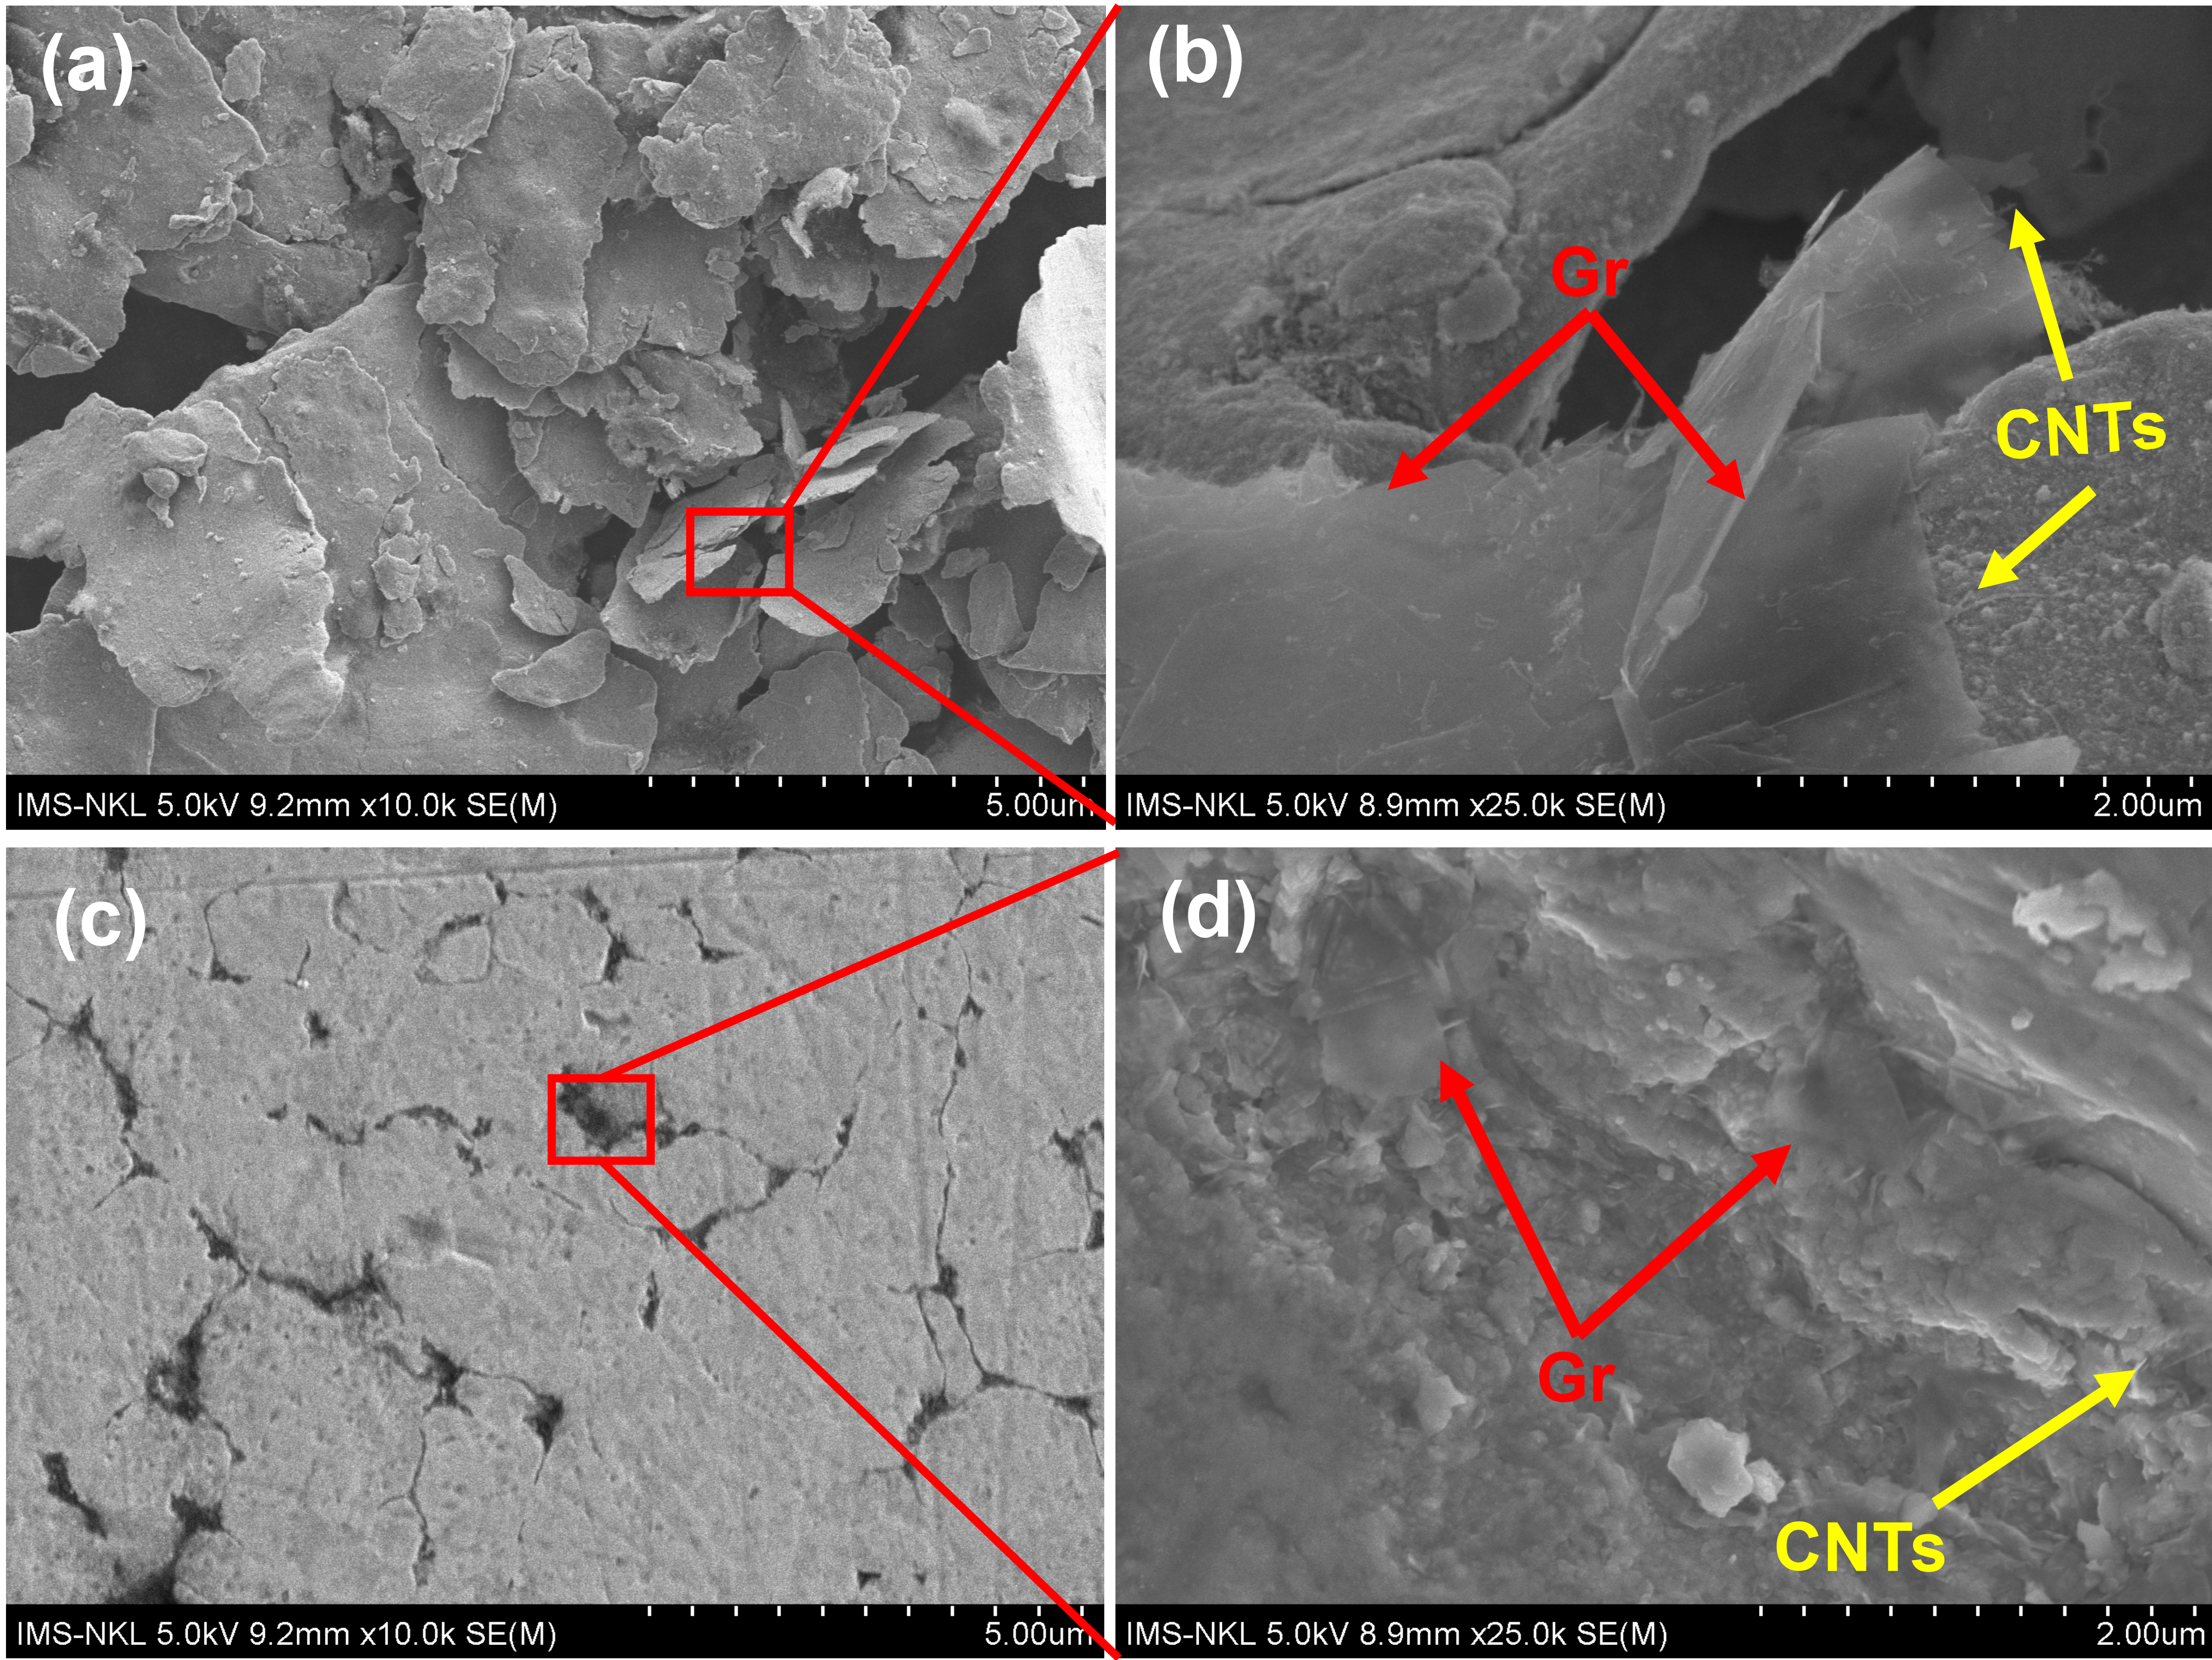
Figure 3. SEM images of (a-b) Gr-CNT/Cu powder and (c-d) Gr-CNT/Cu composite.
Figure 3a-b shows the SEM images of Gr-CNT/Cu composite powder after the milling and mixing process. Observing from the figures, we can see that the copper powder has been deformed after the milling with the Gr-CNT hybrid material. Besides, the Gr-CNT hybrid material has dispersed into the Cu powder which is still in its initial form (Figure 3b). Figure 3c is an SEM image of the Gr-CNT/Cu composite containing Gr-CNT content of 1 vol.% after the consolidation by SPS. As can be observed, the microstructure of the composite material after sintering has high homogeneity. The dispersion of Gr-CNT hybrid materials in the Cu matrix is ​​observed in Figure 3d. As a result, the Gr-CNT hybrid material still exists after the consolidation process and has good bonding with the Cu matrix. EDS spectrum and element mapping of the Gr-CNT/Cu composite were showed in Figure 4. As a result, the compositions of the prepared composites were determined to be 0.45 wt.% for C and 99.55 wt.% for Cu. The measured C content was equivalent to 0.95 vol.%, slightly lower than the designed value (1 vol.%). This could be due to the loss of Gr during the functionalization process of Gr and CNTs. The distribution of C and Cu elements was also presented in Figure 4 (c-d). As can be seen, the C element was unform dispersion within Cu matrix. The obtained results implied that the Gr-CNT/Cu composite was successfully prepared, which is expected to increase the mechanical properties of the material such as hardness and strength of the material.
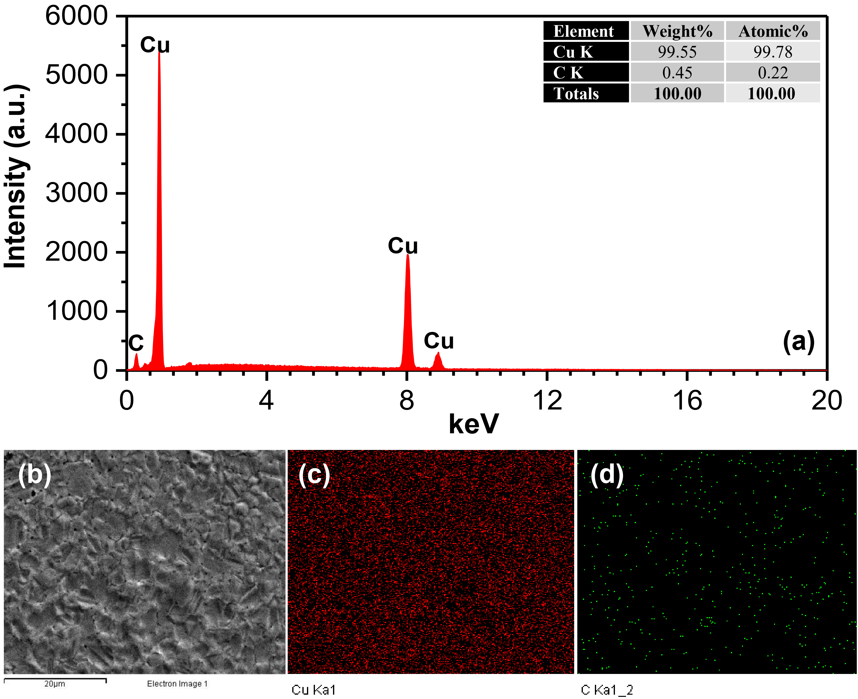
Figure 4. (a) EDS spectrum and (b-d) EDS mapping of Gr-CNT/Cu composite.
3.2. Mechanical properties
Table 1. Density and relative density of Cu and Gr-CNT/Cu composite.
Samples | Theoretical density  (g/cm³) | Measured density  (g/cm³) | Relative density  (%)
Pure Cu | 8.89 | 8.81 ± 0.11 | 99.12 ± 0.39
CNT/Cu composite | 8.82 | 8.69 ± 0.11 | 98.42 ± 0.46
Gr/Cu composite | 8.82 | 8.70 ± 0.11 | 98.69 ± 0.38
Gr-CNT/Cu composite | 8.82 | 8.68 ± 0.12 | 98.34 ± 0.47
The density and relative density of the samples are shown in Figure 5a and Table 1. As a result, the presence of Gr, CNTs and Gr-CNT hybrid material causes the decrease in the density of the prepared composites. This result is consistent with the calculation because the density of Gr (2.2 g/cm³) and CNTs (1.8 g/cm³) is lower than that of Cu (8.89 g/cm³). The relative density was calculated to be 98.42 %, 98.69 % and 98.34 % coresponding to CNT/Cu, Gr/Cu and Gr-CNT/Cu composites, respectively. These values were decreased compared to that of pure Cu (99.12%). This implied that the porosity of the composite increased gradually with the addition of CNTs, Gr and Gr-CNT hybrid material. The high relative density of both Cu and the prepared composites demonstrated that SPS sintering is an effective method in the consolidation of Cu matrix composites reinforced by CNTs, Gr and Gr-CNT hybrid materials.
Figure 5b shows the hardness of the prepared samples. As a result, the prepared composites reinforced by CNTs, Gr or Gr-CNT hybrid materials increased compared to pure Cu, CNT/Cu composite and Gr/Cu composite. When the Gr-CNT hybrid material was added, the hardness of the composite increased with a value of 85.5 HV which is 54 % higher than that of the pure Cu (55.7 HV). It is interesting noted that the hardness of Gr-CNT/Cu composite is higher compared to the composites reinforced by single phase reinforcement (CNTs or Gr). This can be explained that the matrix material can transfer and distribute external forces acting on the reinforcement. Gr-CNT has high mechanical properties thus leading to enhancing the mechanical properties of the Gr-CNT/Cu composite [11,27]. On the other hand, the hardening here follows the mechanism of dispersion hardening characterized by the movement of dislocations. In this case, Gr-CNT acts as a pin that hinders the movement of dislocations. The dislocations need more energy to move, thereby increasing the mechanical properties of the material.
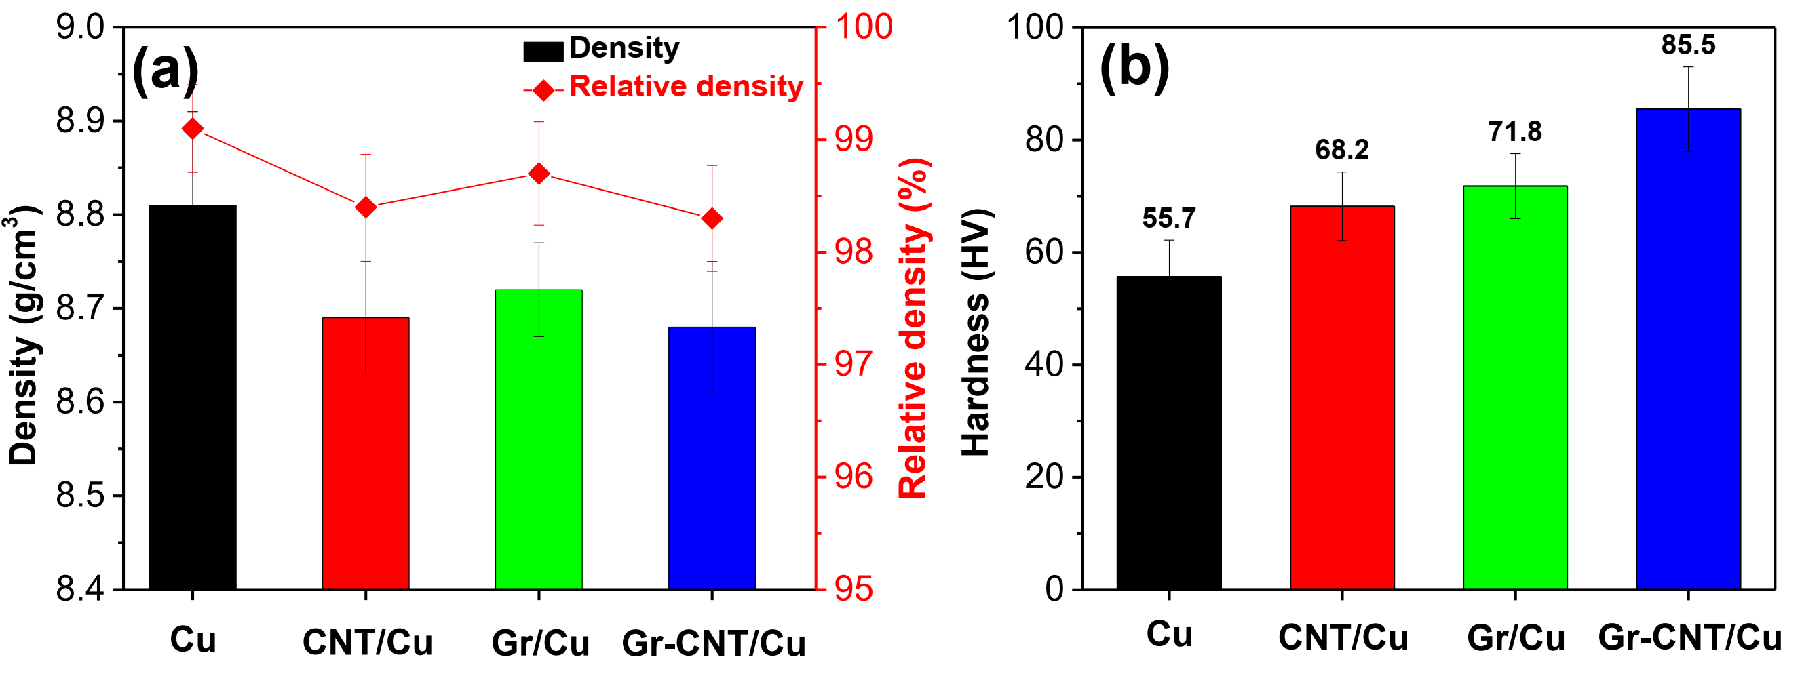
Figure 5. (a) Density and relative density and (b) hardness of the prepared samples.
Figure 6a is the stress-strain characteristic curve of pure Cu, CNT/Cu composite, Gr/Cu composite and Gr-CNT/Cu composite. Accordingly, we can see that the yield strength of the composite increased when compared to pure Cu. The yield strength of the composite material reinforced by Gr-CNT hybrid materials increases by 33 %, 19 % and 21 % compared to pure Cu, CNT/Cu and Gr/Cu composite, respectively. The tensile strength of the Gr-CNT/Cu composite reaches the highest value of 225.5 MPa, which is increased up to 50 % compared to pure Cu. The increase in the tensile strength of the prepared composite could be due to the presence of Gr-CNT hybrid material, and the load transfer from the matrix to the reinforcement material. In addition, the significantly synergistically strengthened composite reinforced by Gr-CNT hybrid materials compared to CNT/Cu composite and Gr/Cu composites could be resulted from π-π bonding network between Gr and CNTs [23, 24]. Furthermore, the difference in the thermal expansion coefficient of Cu and Gr-CNT can cause some dislocations in the composite during sintering. The formation of dislocations at the contact layer between Cu and Gr-CNT leads to an increase in the hardness and tensile strength of the composite. In addition, the mechanical properties of the composite material could be enhanced by other strengthening mechanisms such as grain refinement and Orowan, etc [28, 29].
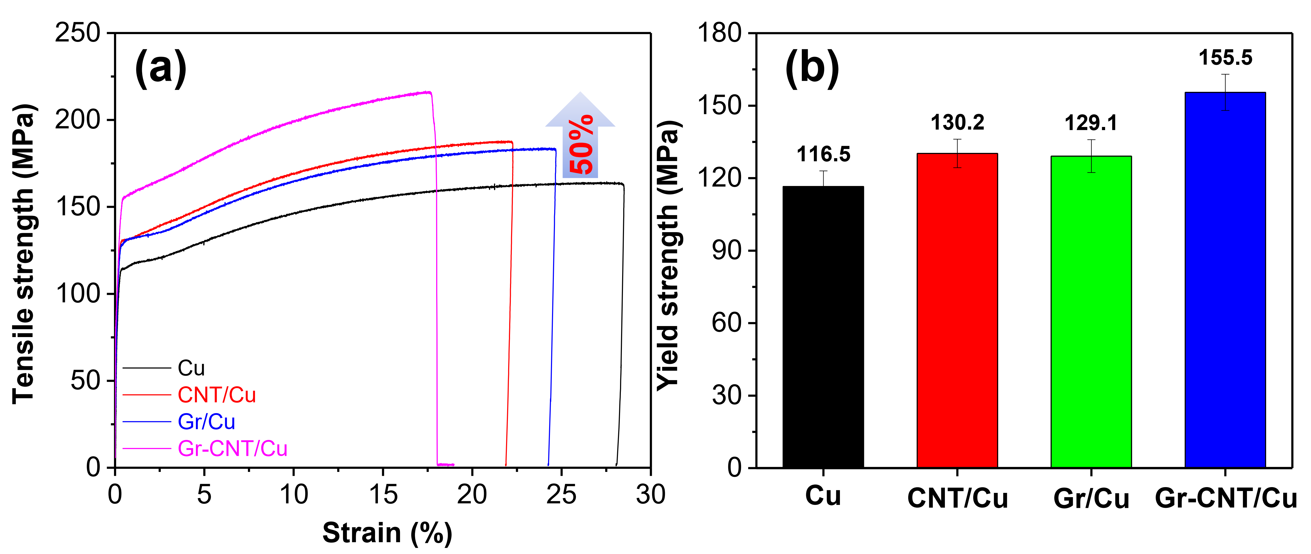
Figure 6. (a) Stress-strain characteristic and (b) yield strength of the prepared samples.
3.3. Wear behavior
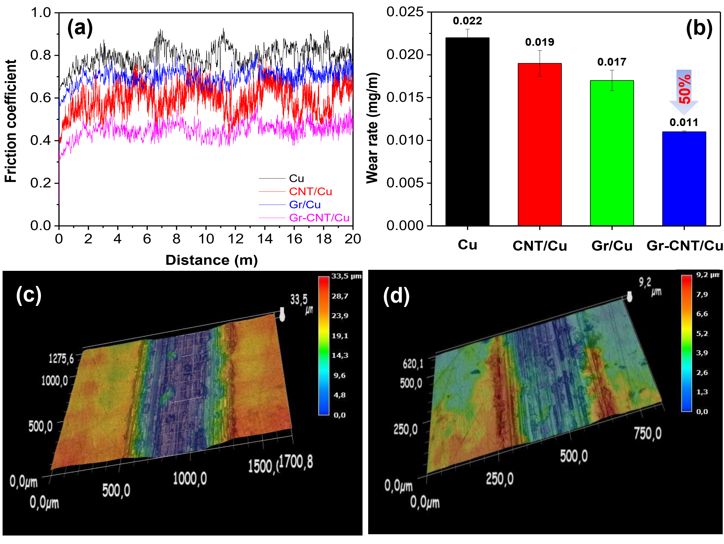
Figure 7. (a) The friction coefficient (b) wear rate of prepared samples and Optical images of wear track of (c) Cu and (d) Gr-CNT/Cu composite
The wear behavior of pure Cu and CNT-Gr/Cu composites was investigated and presented in Figure 7. The friction coefficient of pure Cu, CNT/Cu composite, Gr/Cu composite and CNT-Gr/Cu composites was tested with steel balls under a load of 5N (Figure 7a). The average friction coefficient of the composite (0.41) decreased by 43 %, 33 % and 37 % compared to the pure Cu, CNT/Cu composite and Gr/Cu composite, respectively. The decrease in the friction coefficient of the composite reinforced by Gr-CNT hybrid material demonstrated the good wear resistance of the prepared composites compared to other samples. This could be explained by the Gr-CNT hybrid material breaking to produce a carbon coating on the wear track during the wear test [30]. This film has high wear resistance, thereby reducing the coefficient of friction of the composite. The change in average friction coefficient accompanied by the change in wear rate of the CNT-Gr/Cu composites is shown in Figure 7b. The obtained result indicated that the wear rate of the composite is 50 % lower than that of pure Cu. The reduction in the wear rate of the composite is consistent with the coefficient of friction under the effect of the material composition. Besides. observation of the optical images shows that the track after testing has different sizes depending on the material compositions. The tracks exhibited larger widths and depths for pure Cu and smaller sizes for the CNT-Gr/Cu composites (Figure 7c-d). The obtained results demonstrated the Gr-CNT/Cu composite exhibited a good wear resistance compared to the Cu composite reinforced by CNTs or Gr.
4. Conclusions
We have investigated the effect of Gr-CNT hybrid materials on the microstructure and properties of Gr-CNT/Cu composite consolidated by the SPS technique. The Gr-CNT hybrid material was dispersed on the surface of Cu particles after the ball milling process The Gr-CNT/Cu composite was successfully fabricated with a relative density higher than 98 %. The hardness of the composite increased compared to the pure Cu and reached 85.5 HV. The tensile strength of the composite was measured to be 225.5 MPa which is 50 % higher compared to pure Cu. The increase in hardness and tensile strength were attributed to the presence of Gr-CNT hybrid material. The friction coefficient and wear rate of the composite decreased by 43 % and 50 % compared to pure Cu under the applied load of 5N, respectively. The decrease in friction coefficient and wear rate of the composite demonstrated the vital of Gr-CNT hybrid material on the increase of wear resistance of the composite.
Acknowledgements. This research is funded by Vietnam Academy of Science and Technology (VAST) under grant number KHCBVL.01/22-23.
CRediT authorship contribution statement. Conceptualization, D.D.P and P.V.T.; T.B.T, P.V. and B.H.T; formal analysis, D.D.P. and P.V.T; investigation, T.B.T. and D.D.P; writing—original draft preparation, P.V.T, and D.D.P; writing—review and editing, P.V. T, P.N.M and D.D.P; supervision, P.N.M and D.D.P. All authors have read and agreed to the published version of the manuscript.
Declaration of competing interest. The authors declare no possible conflict of interests.
References
1. Bai X., Wang D., Zhen L., et al. – Micromanufacturing of composite materials: a review. International Journal of Extreme Manufacturing, 1 (2019) 012004. doi.org/10.1088/2631-7990/AB0F74.
2. Mortensen A., Llorca J. – Metal matrix composites. Annual Review of Materials Research, 40 (2010) 243–270. doi.org/10.1146/ANNUREV-MATSCI-070909-104511/CITE/REFWORKS.
3. Parikh V. K., Patel V., Pandya D. P., Andersson J. – Current status on manufacturing routes to produce metal matrix composites: State-of-the-art. Heliyon, 9 (2023) e13558. doi.org/10.1016/J.HELIYON.2023.E13558.
4. Sharma S. K., Saxena K. K., Salem K. H., Mohammed K. A., Singh R., Prakash C. – Effects of various fabrication techniques on the mechanical characteristics of metal matrix composites: a review. Advances in Materials and Processing Technologies, 10 (2024) 277–294. doi.org/10.1080/2374068X.2022.2144276.
5. Yoo S. C., Lee D., Ryu S. W., Kang B., Ryu H. J., Hong S. H. – Recent progress in low-dimensional nanomaterials filled multifunctional metal matrix nanocomposites. Progress in Materials Science, 132 (2023) 101034. doi.org/10.1016/J.PMATSCI.2022.101034.
6. Qin Y. –Q, Tian Y., Peng Y. –Q, et al. – Research status and development trend of preparation technology of ceramic particle dispersion strengthened copper-matrix composites. Journal of Alloys and Compounds, 848 (2020) 156475. doi.org/10.1016/J.JALLCOM.2020.156475.
7. Jamwal A., Mittal P., Agrawal R., et al. – Towards sustainable copper matrix composites: Manufacturing routes with structural, mechanical, electrical and corrosion behaviour. https://doi.org/101177/0021998319900655, 54 (2020) 2635–2649. doi.org/10.1177/0021998319900655.
8. Somani N., Sharma N., Sharma A., Gautam Y. K., Khatri P., Solomon J. A. A. – Fabrication of Cu-SiC Composites using Powder Metallurgy Technique. Materials Today: Proceedings, 5 (2018) 28136–28141. doi.org/10.1016/J.MATPR.2018.10.055.
9. Somani N., Gupta N. K. – Effect of TiC nanoparticles on microstructural and tribological properties of Cu-TiC nano-composites. Proceedings of the Institution of Mechanical Engineers, Part B: Journal of Engineering Manufacture, 236 (2022) 319–336. doi.org/10.1177/09544054211029828.
10. Trinh P. Van, Luan N. Van, Phuong D. D., Minh P. N. – Mirostructure and microhardness of aluminum-copper composite reinforced with multi-walled carbon nanotubes prepared by vacuum sintering and hot isostatic pressing techniques. Science of Sintering, 50 (2018) 163–171. doi.org/10.2298/SOS1802163T.
11. Phuong D. D., Van Trinh P., Minh P. N., Shtertser A. A., Ulianitsky V. Y. – Effect of Powder Preparation Techniques on Microstructure, Mechanical Properties, and Wear Behaviors of Graphene-Reinforced Copper Matrix Composites. Crystals 2024, Vol 14, Page 1000, 14 (2024) 1000. doi.org/10.3390/CRYST14111000.
12. Van Duong L., Anh N. N., Trung T. B., et al. – Effect of annealing temperature on electrical and thermal property of cold-rolled multi-walled carbon nanotubes reinforced copper composites. Diamond and Related Materials, 108 (2020) 107980. doi.org/10.1016/J.DIAMOND.2020.107980.
13. Van Hau T., Van Trinh P., Van Tu N., et al. – Electrodeposited nickel–graphene nanocomposite coating: influence of graphene nanoplatelet size on wear and corrosion resistance. Applied Nanoscience (Switzerland), 11 (2021) 1481–1490. doi.org/10.1007/S13204-021-01780-0/FIGURES/11.
14. Li Z., Zhao L., Guo Q., et al. – Enhanced dislocation obstruction in nanolaminated graphene/Cu composite as revealed by stress relaxation experiments. Scripta Materialia, 131 (2017) 67–71. doi.org/10.1016/J.SCRIPTAMAT.2017.01.015.
15. Chu K., Wang X. hu, Li Y. biao, et al. – Thermal properties of graphene/metal composites with aligned graphene. Materials & Design, 140 (2018) 85–94. doi.org/10.1016/J.MATDES.2017.11.048.
16. Hidalgo-Manrique P., Lei X., Xu R., Zhou M., Kinloch I. A., Young R. J. – Copper/graphene composites: a review. Journal of Materials Science, 54 (2019) 12236–12289. doi.org/10.1007/S10853-019-03703-5/FIGURES/41.
17. Zhang L., Duan Z., Zhu H., Yin K. – Advances in synthesizing copper/graphene composite material. Materials and Manufacturing Processes, 32 (2017) 475–479. doi.org/10.1080/10426914.2016.1198036.
18. Janas D., Liszka B. – Copper matrix nanocomposites based on carbon nanotubes or graphene. Materials Chemistry Frontiers, 2 (2017) 22–35. doi.org/10.1039/C7QM00316A.
19. Song G., Sun L., Li S., Sun Y., Fu Q., Pan C. – Synergistic effect of Gr and CNTs on preparing ultrathin Cu-(CNTs+Gr) composite foil via electrodeposition. Composites Part B: Engineering, 187 (2020) 107841. doi.org/10.1016/J.COMPOSITESB.2020.107841.
20. Zarei F., Sheibani S. – Comparative study on carbon nanotube and graphene reinforced Cu matrix nanocomposites for thermal management applications. Diamond and Related Materials, 113 (2021) 108273. doi.org/10.1016/J.DIAMOND.2021.108273.
21. Chen X., Tao J., Yi J., Liu Y., Li C., Bao R. – Strengthening behavior of carbon nanotube-graphene hybrids in copper matrix composites. Materials Science and Engineering: A, 718 (2018) 427–436. doi.org/10.1016/J.MSEA.2018.02.006.
22. Zhao Q., Gan X., Zhou K. – Enhanced properties of carbon nanotube-graphite hybrid-reinforced Cu matrix composites via optimization of the preparation technology and interface structure. Powder Technology, 355 (2019) 408–416. doi.org/10.1016/J.POWTEC.2019.07.055.
23. Cao J., Yang Q., Zhou L., et al. – Microstructure, properties and synergetic effect of graphene oxide-functionalized carbon nanotubes hybrid reinforced copper matrix composites prepared by DC electrodeposition. Carbon, 212 (2023) 118157. doi.org/10.1016/J.CARBON.2023.118157.
24. Chen X., Tao J., Liu Y., et al. – Interface interaction and synergistic strengthening behavior in pure copper matrix composites reinforced with functionalized carbon nanotube-graphene hybrids. Carbon, 146 (2019) 736–755. doi.org/10.1016/J.CARBON.2019.02.048.
25. Van Hau T., Van Trinh P., Hoai Nam N. P., et al. – Electrodeposited nickel–graphene nanocomposite coating: effect of graphene nanoplatelet size on its microstructure and hardness. RSC Advances, 10 (2020) 22080–22090. doi.org/10.1039/D0RA03776A.
26. Van Duong L., Van Luan N., Ngoc Anh N., et al. – Enhanced mechanical properties and wear resistance of cold-rolled carbon nanotubes reinforced copper matrix composites. Materials Research Express, 7 (2020) 015069. doi.org/10.1088/2053-1591/AB69C1.
27. Zhang S., Huang P., Wang F. – Graphene-boundary strengthening mechanism in Cu/graphene nanocomposites: A molecular dynamics simulation. Materials & Design, 190 (2020) 108555. doi.org/10.1016/J.MATDES.2020.108555.
28. Wang Y., Cheng H., Sun B., et al. – Enhanced electrical and mechanical properties of graphene/copper composite through reduced graphene oxide-assisted coating. Journal of Materials Research and Technology, 33 (2024) 8121–8131. doi.org/10.1016/J.JMRT.2024.11.162.
29. Yu J., Wang L., Shao B., Zong Y. – The role of graphene interlayer slipping on the deformation behavior of graphene/copper composite. Journal of Alloys and Compounds, 988 (2024) 174142. doi.org/10.1016/J.JALLCOM.2024.174142.
30. Xu Y., Zhou P., Chen Q., et al. – The effect of copper particles coated with graphene oxide on tribological properties and tribo-layers of copper metal matrix composites. Tribology International, 199 (2024) 110041. doi.org/10.1016/J.TRIBOINT.2024.110041.

